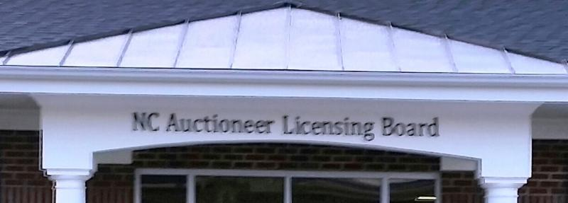

NC EXECUTIVE ORDER No. 176
PHASE 3-Extended/Modified

Governor Roy Cooper has signed Executive Order No. 176, regarding COVID-19. Executive Order 176 takes effect on Friday, November 13th at 5 p.m., and remains in effect until 5 p.m. on December 4th, unless replaced or rescinded by a subsequent Executive Order. Please review the Order carefully, as it includes revised mandates involving Mass Gathering Limits, Social Distancing, Face Coverings, and other issues relevant to auction activity. Executive Order No. 176 can be viewed at this link: https://files.nc.gov/governor/documents/files/EO176-Phase-3-ext.pdf

Click this link to view a Frequently Asked Questions for Executive Order No. 176 - Phase 3-Extended: https://files.nc.gov/governor/documents/files/EO-176-FAQ.pdf

NOV. '20 NCALB MESSAGE - Governor's Ex. Order 176'
NC Auctioneer Licensing Board | 108 Ber Creek Drive, Fuquay-Varina, NC 27526
Unsubscribe info@ncalb.org
Update Profile | About our service provider
Sent by info@ncalb.org powered by

Try email marketing for free today!

